**EHB211E Basics of Electrical Circuits**

**Müştak E. Yalçın (CRN: 12622)**

**Homework #1 Report**

**26/11/2012**

**Student Name: Tuğrul YATAĞAN**

**Student Number: 040100117**

1. **LTspice IV Circuit Schematic:**

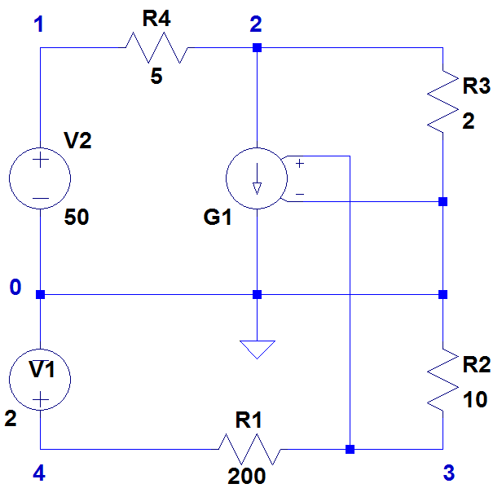

1. **The Spice Netlist Code:**

R4 N002 N001 5

R3 N002 0 2

R2 0 N003 10

R1 N003 N004 200

V2 N001 0 50

V1 N004 0 2

G1 N002 0 N003 0 10

.backanno

.end

1. **DC Operating Point Values:**

--- Operating Point ---

V(n002): 12.9252 voltage

V(n001): 50 voltage

V(n003): 0.0952381 voltage

V(n004): 2 voltage

I(R1): -0.00952381 device_current

I(R2): -0.00952381 device_current

I(R3): 6.46258 device_current

I(R4): -7.41497 device_current

I(G1): 0.952381 device_current

I(V1): -0.00952381 device_current

I(V2): -7.41497 device_current